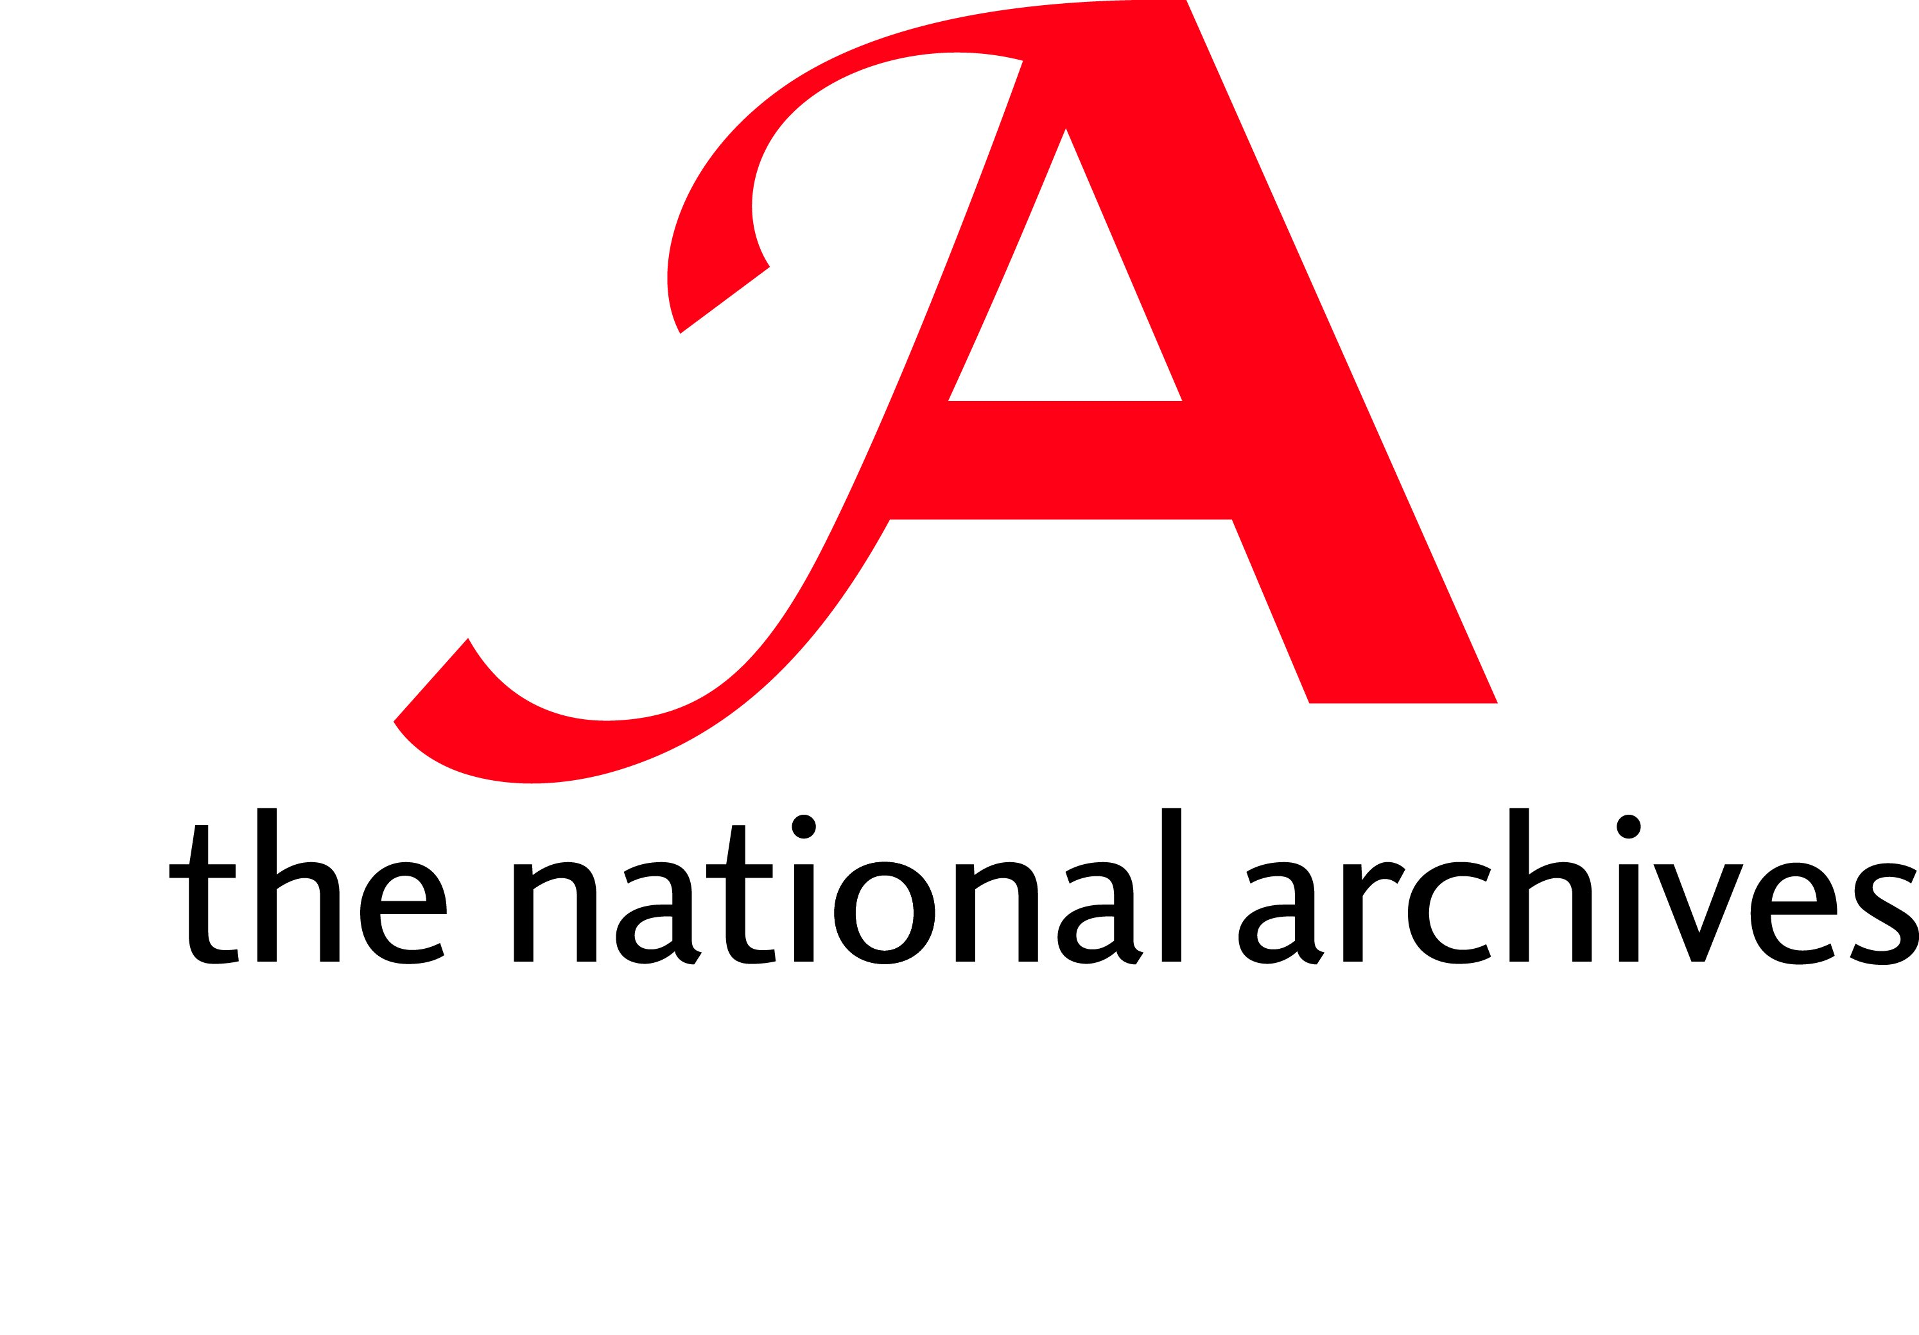

The National Archives

Guidelines for the Conservation of Paper Manuscripts

(Draft1)

September 2003

These guidelines are to be used in conjunction with BS 4971 ‘Repair and Allied Processes for the Conservation of Documents’.

CONTENTS

- Ethics

- Numbering, stamping, formats etc.
2.1 Purpose
2.2 Guidelines/procedures
2.3 Location
2.4 Formats
2.5 Missing on documents prior to transfer
2.6 Missing documents after transfer
2.7 Missed Numbers
2.8 Missed Document
2.9 Cancelling a Number
2.10 Extracts
2.11 Stamping

- Materials used for the treatment of paper manuscripts: standards
- Papers
- Mechanical cleaning
- Adhesives/Consolidants/Sizes
- Chemical Solvents
- Guidelines
- Plastic Films
3.6 Tapes, threads and cords

- Treatments: Mechanical cleaning
4.1 Purpose
4.2 Special considerations
4.3 Guidelines

- Treatments: Paper washing and drying
5.1 Purpose
5.2 Special considerations
5.3 Guidelines

- Treatment: Re- Sizing
6.1 Purpose
6.2 Special considerations
6.3 Guidelines

7. Treatments: De-acidification
7.1 Purpose
7.2 Special considerations
7.3 Guidelines
7.4 Choice of De-acidifying Agent

8. Consolidation and fixing
8.1 Purpose
8.2 Special considerations
8.3 Guidelines

9. Repair
8.1 Purpose
8.2 Special considerations
8.3 Guidelines

- Ethics

- All treatments, including any materials used should be fully documented.
- Any treatment should be considered in the light of the of the item(s), condition, expected use and intrinsic value.
- The integrity of the document should be retained as an historical artefact and as a carrier of information.
- Only the minimum amount of treatment should be carried out to ensure the item can be handled safely and preserved for the future. Repairs should be detectable, sympathetic, and should not obscure or diminish the image.
- The intention of any conservation treatment should be such that future treatment is not precluded, although exceptions to this can be made when deterioration is so extreme that removal of the repair may cause further loss or damage.
- All materials used must be of an acceptable conservation standard and compatible with all elements of the document both in the short- and long-term.
- No attempt should be made to enhance or fabricate the text or image.
- Existing repairs should be retained unless they are disfiguring, causing mechanical or chemical damage, or their removal is necessary for treatment. All repairs should be recorded if they are to be removed.
- Original formats should be retained as much as possible. Any alterations should be justified and recorded.
- Removal or retention of blank sheets is discretionary but removal must be justified and documented.
- The blank half of a folio must not be discarded.

- All storage materials (boxes, wrapping, enclosures, etc.) should be appropriate in terms of strength, size, and material, and should physically protect the item and provide a buffer against environmental hazards.
- No unsupervised work should be undertaken without adequate experience and ability.

- Numbering, Stamping, Formats etc.

  - Purpose
Manuscripts in The National Archives (TNA) are:

- numbered to ensure that they are kept in the correct order.

and

- stamped using the TNA stamp for security purposes

  - Guidelines/procedures
- establish that numbering is necessary before carrying out any necessary treatment
- establish that the documents are in order before numbering. Seek specialist advice if necessary.
- temporary pencil numbering should not be used if the document is to undergo aqueous treatment since this will fix the graphite to the paper.
- ascertain before discarding blank sheet/s whether there is any faded text that could be visible under UV light.
- if the document does not already carry a visible TNA stamp this should be added after treatment
- do not number or stamp over existing text or detail
- be aware of over or under inking TNA stamp
Use only (name ink used to stamp documents)

  - Location
- any numbering or stamping using the TNA stamp should where possible be applied to the verso of the document at bottom left corner or as near as possible ( e.g. avoiding weak paper or the image)
- initial numbering may be in pencil (HB or B) or with a numerator.
- final numbering can be on the document or on the repair at the individual’s discretion using a numerator unless there is a specific reason for not doing so (e.g. superscripts and END)

2.4 Formats

Single Items:
- it is advisable to put the complete reference (in pencil) on a single unsecured item being placed in an enclosure. (e.g. ADM 12/345 1 END)

Loose Documents:
- single sequence - the final number should have END written after it (include cover if applicable)
- alternative sequences - seek specialist advice (e.g. rolls within rolls)
- a document comprising of a number of documents sewn or adhered together should be each numbered separately

Tagged Files:
- single sequence - the final number should have END written after it (include cover/s if applicable)

Pamphlet Styles:
- Unless previously numbered, treat each individual pamphlet as for Loose Documents unless otherwise directed. See also Multiple Formats

Multiple Formats:
- collections of mixed formats-
- tagged files containing miscellaneous material including pamphlets should be numbered as for Loose Documents
- boxes of miscellaneous formats e.g. single parchments plus pamphlets may require a different numbering sequence. Advice should be sought.

Covers:
- Whether or not the front and back cover/s are blank, both should be numbered and stamped with the TNA identification stamp.

  - Missing on documents prior to transfer
- documents should contain notification that item/s are ‘Missing on Transfer’ from a Government Department to TNA. The notification sheet should be of archival quality and numbered.

  - Missing documents after transfer
- documents misplaced or lost after transfer from a Government Department to TNA should have a dummy sheet inserted stating that the page/s is MISSING and the date that this was discovered. The dummy sheet should be of archival quality and numbered.

  - Missed Numbers
- if a number has been accidentally omitted when numbering, a dummy sheet should be placed in the position stating NUMBER NOT USED. The dummy sheet should be of archival quality.

  - Missed Document
- should a document/s be missed during numbering the following procedure should be adopted:-

1 2 3 4 (single missed document) 5 6 (two missed documents) 7 8 9

1 2 3 4 ^{A} 4^{B-} 5 6 ^{A} 6 ^{B} 6 ^{C-} 7 8 9

- the last super-scripted letter in the alphabetical sequence must be followed by a dash.

- if subsequent to a previous numbering sequence material has been added in front of page 1 then the additional material becomes 1 ^{A} and the original number 1 becomes 1 ^{B-} .

  - Cancelling a Number
- if cancelling an earlier number, use a single diagonal pencil stroke from right to left e.g. / . The original number must not be obscured as it may have been used for cross referencing.

2.10 Extracts
- the current guidelines must be followed.

2.11 Stamping
- TNA stamp should be added above the number where possible.

- Materials used for the treatment of paper manuscripts

  - PAPERS

Both hand-made and machine made papers should be:

- neutral pH (or in the range 6.0 to 9.0)
- colourfast
- gelatine, starch or modern AKD or ASA sized
- free of alum or alum rosin sizes
- contain calcium carbonate or acceptable alkaline equivalent as filler
- have reasonable wet strength (with exception of Japanese papers and some tissues)
- free of detrimental additives
- free of available chlorine and sulphur

Composition: Papers, including recycled papers should ???

- have minimum lignin content
- comply with paper standards (as set out in?)

3.2 Materials used for mechanically cleaning paper

Erasers
- vinyl erasers should be used in preference to other plastics or latex ones.
- products should be free of chlorine and sulphur.
- products should be free of plasticisers e.g. dioctyl phthalate.
- chemical sponges/smoke sponges are useful for removing heavy surface dirt, followed by more thorough with a vinyl eraser.

3.3 Adhesives, consolidants and sizes

The following guidelines apply to both natural and synthetic products. (NB traditional adhesives, i.e. starch and gelatine, do not conform in all particulars to the standards detailed below.)

Adhesives, Consolidants and Sizes should:
- have a pH between 5.5 and 8.5

and be -

- reversible after ageing in a moderately safe and easily available solvent without damage to the document, inks or other media or binders
- free of chemically reactive additives
- stable and have good ageing properties
- flexible after application and remain so
- colourless as possible and remain so
- reasonably resistant to mould and insect attack in appropriate storage conditions
- compatible with medium/substrate
- have adequate slip, tack and open time appropriate to the job
- appropriate grade for the purpose required
- appropriate consistency for the purpose required
- highly refined if appropriate e.g. gelatine
- gluten free, i.e. starch

should not:
- be excessively hygroscopic
- contain plasticisers
- shrink excessively on drying and ageing
- migrate or become tacky at room or storage temperatures (i.e. should have reasonably high Tg
- contain fumigants

NB Suitable synthetics (e.g. PVA) and animal glues etc. can be used if not in direct contact with the document, e.g. the recommendation for file boards, enclosures and custom made boxes to off-gas is 30 days

  - Solvents: Chemical

Health and Safety Conservators should be informed of, and pay due regard to, any health and safety procedures related to the use of chemicals.

Uses
- removal of non-water soluble adhesives
- stain removal or reduction
- solvent and carrier for water soluable consolidants/sizes/adhesives
(e.g. acrylic resins)
- aid to water/moisture penetration

3.5 Guidelines
All chemicals should:
- be used in compliance with COSHH and /or any other Health and
Safety directives
- not damage the image or substrate
- be appropriate for the purpose
- be used in the correct proportions to the solution for the purpose
required
- be the least innocuous solvent that will successfully fulfil the purpose
required.
- be disposed of responsibly

3.6 Plastic Films

This includes polyester (Melinex, Perspex, Mylar) polypropylene etc.

Should:
- be inert
- remain flexible
- remain transparent
- remain colourless
- be anti-static
- ‘breathe’
- have reasonably high Tg
- contain minimal plasticisers ???

Should not:
- contain chlorine
- contain sulphur
- cross link

3.7 Tapes, Threads and Cords

Should:
- be of vegetable or inert synthetic fibre (e.g. polyester)
- be un-waxed
- be un-bleached
- un-dyed
- have long term durability

4. Mechanical Cleaning Paper (See 3.3 for materials
used to mechanically clean items)

  - Purpose:
Mechanical surface cleaning is the first, and sometimes the only treatment a
paper artefact will receive.
- mechanical cleaning is carried out to remove surface dirt and/or loose mould spores.
- improve the overall appearance of an object
- to minimize the amount of dirt transferred to another sheet.

4.2 Special considerations
Mechanical cleaning is an irreversible treatment and therefore it should only
be undertaken in the context of the condition of the document, surface
texture, and the presence of friable materials such as graphite. Mechanical
cleaning can:
- abrade the surface or permanently alter the paper surface
- remove, diminish or disrupt the image (e.g. pencil markings, friable inks etc.)
- leave unsightly marks ( e.g. streaking)
- leave behind visible residues of the cleaning agent

4.3 Guidelines
- brushing of heavily soiled materials should be carried out in a fume cabinet
and wearing protective clothing if necessary.
- surface cleaning can be carried out using brushes, erasers, or latex sponges,
depending on the degree of dirt and the nature of the document (See 3.3)

5.0 Paper Washing and Drying

  - Purpose :
The purpose of aqueous cleaning is to remove soluable acids in the paper,
and in some cases improve the appearance of the sheet. Washing can be an
independent treatment or it can be used in conjunction with other treatments.
E.g. to remove residual chemicals or adhesives.

5.2 Special Considerations
- Some specialist papers and surface coatings should not be wetted. It is not
generally appropriate to wash sound, clean paper.
- Washing can affect the tonal quality of many inks, reduce the density of the
inks and alter the surface characteristics of the sheet.
- Documents written in iron-gall ink should not be washed. XXX dyes as
well as all other media may be affected. Washing will alter he size or cause
permanent dimensional changes.

5.3 Guidelines
- washing should be preceded by mechanical cleaning unless the fragility of
the document makes this impossible
- washing should not be undertaken without testing for fugitive inks. Many
inks are fugitive to different degrees depending on the binder and density
of the ink, particularly iron gall inks, coloured inks and pencil.
- washing should not be undertaken without testing for media/binder
solubility.
- ideally wash in running water to flush away the impurities. Alternatively
change water regularly until the water shows no visible colour change.
Better results are achieved with gently moving water in order to flush the
dirt out of the fibres Inadequate washing can be detrimental. The duration
will vary according to the condition of the document - minimum of 30
minutes.
- items must be adequately supported during washing. items can be
washed singly or in small multiples (approximately 5). after washing in
batches ensure that there is complete water penetration throughout the
batch.
- allow to dry or partially dry before considering de-acidification. Washing may preclude the necessity for de-acidification.

Alternatives to immersion washing:
- float washing ?? explain

- Treatment: Re-sizing paper documents

  - Purpose:
To add mechanical strength to a very fragile or damaged paper, to replace
the original size that has been wholly or partially removed in the washing
process

  - Special Considerations:
resizing is a irreversible process and should only be undertaken when the
paper is very soft or weak. The choice of sizing agent will depend on a
number of factors including the condition of the sheet and the sensitivity of
the media.
The size most frequently used is dilute refined gelatine as this is the type
of size traditionally used in western early paper manufacture: although
partially replaced by alum rosin sizing and now by alkaline sizes, gelatine is
still the most likely size to be removed during the washing process of older
papers.

  - Guidelines
Aqueous sizing agents
- if a non-water soluble size is to be used the inks must be tested for
stability to the solvent involved
- re-sizing should be carried out on dry paper documents that have been
washed.
- sizing is normally carried out after completion of repairs. The size should
completely penetrate the whole document
- application can be with a brush or spray the document must be left to air
dry
- the paper should not be left shiny or stiff

Non-aqueous sizing agents ????

7.0 Treatments: Deacidification of Paper

7.1 Purpose:
to further reduce the soluble acids in paper and to, provide an alkaline
buffer to inhibit deterioration of paper.

(Note that some paper fibres, e.g. hemp, are naturally more acidic than others).

7.2 Special considerations
If the item appears in good condition with no visible appreciable signs of
deterioration, de-acidification is not necessary. Bear in mind that some
paper fibres are more naturally acidic than others, but nevertheless very
durable, and the results of chemical interference are unpredictable.

7.3 De-acidification should only be undertaken if:
- there is no over-riding necessity to retain the physical and chemical
integrity of the item. the item is below pH 5.0 - 5.5
- no component of the media (e.g. hardeners/binders etc. as well as the
colouring agent itself) is alkaline sensitive.
- iron gall inks need to be considered in this category as they may lose
intensity, although an over-acidic ink m ay benefit.
- no component of the media is sensitive to the de-acidification

Guidelines to De-acidification of Paper carrier (water or organic solvent)

7.4 Choice of De-acidifying Agent:
- neither the agent or carrier should damage any aspect of the paper or the
media.
- the agent should preferably contain a buffer.
- alkaline sensitive images ???
- magnesium should be used in preference to Calcium as it is less harsh.
- bicarbonates should be used in preference to hydroxides for a more
moderate alkalinity - (the end results should not be above pH 9.0)
- non-aqueous de-acidification may be more convenient for large
numbers of documents
- possible health considerations ( e.g. if an organic solvent is to be used
and no fume cabinet is available.

- Consolidation and fixing inks and pigments

  - Purpose:
  - to re-attach flaking inks or pigments to the paper.
  - to re-adhere flaking ink or pigment particles
  - to protect inks or pigments during wet treatments or
treatments using a solvent different from that of the fixative and to
which it is not soluble

8.2 Special considerations
The appearance of the document should not be altered

8.3 Guidelines

(Note: as the fixative is seldom removable wholly or in part the standards for consolidants generally should be followed (See 3.4)) humidification of paper or parchment can sometimes soften media binders sufficiently to enable re-adherence.

- any necessary Health and Safety procedures should be followed.
- the consolidant must conform to the specifications laid out in 3.4
- application should follow mechanical cleaning unless the item is too
fragile for the latter to take place.
- inks/pigments must be tested with the solvent to be employed before
application
- a consolidant should not change surface qualities or the refractory index
of the sheet
- application can be by brush, fine spray or misting.
- if a consolidant is available in different grades or code numbers then
the correct one for the purpose must be selected (e.g. Methyl cellulose
and Paraloid)
- the correct ratio of consolidant to solvent must be used
- inks and pigments must be tested for stability to the solvent before
application
- the correct proportion to solvent should be ????
- if re-adherence to the substrate is required application should be with
a fine brush beneath the pigment not on top of it.
- alcohol can be used to aid penetration beneath the pigment or flaking
ink
- application should not leave a shine

9.0 Repair

9.1 Purpose

9.2 Special considerations

9.3 Guidelines

Verso is the back of leaf; recto is the front
alkyl ketene dimers (e.g. Aquapel)
alkenyl succinic anhydrides
ISO 9706:1994 specifies standards for permanent paper including minimum calcium carbonate , or equivalent, content
epichloryhydride resin used as wet strengthener in manilla spider tissue is currently considered to be archivally acceptable
Particularly important for work with photographic images
pulps (papers?) with high lignin content are vulnerable to sulphur dioxide absorption
starches (e.g. wheat, rice, potato etc.), animal derivatives (gelatine e.g. fish glue, parchment size etc.); seaweed (alginates); cellulose derivatives e.g. methyl cellulose
acrylics e.g. Paraloid B72
Traditional adhesives continue to be used as their qualities are well known and predictable and are considered to compare favourably with more modern adhesives.
Removal will seldom be total as some residue will inevitably remain; in some accepted cases removal is going to be impossible without partial or total destruction of the document (eg. In the case of so badly degraded and fragile documents that consolidation is the final option)
Glass transition temperature
An apparently strong clean paper may record a low pH reading. Washing or de-acidification may disturb this chemical equilibrium.
This can redistribute harmful metal ions (iron and copper) and re-activate acids.
There is concern that when using nylon mesh that dirt can be trapped and held in the weave and be transferred back into the document. (Never dry a document on the mesh as the pattern of the weave will be visible on the paper)
Gelatine is used at about 2% gelatine to water and must be applied warm.
Strong de-acidifying agents can cause bleaching
Note that the lower the concentration the greater degree of penetration of the material: a volatile chemical solvent will eveporate off too quickly to allow time for a heavy concentration to pass in to the material

